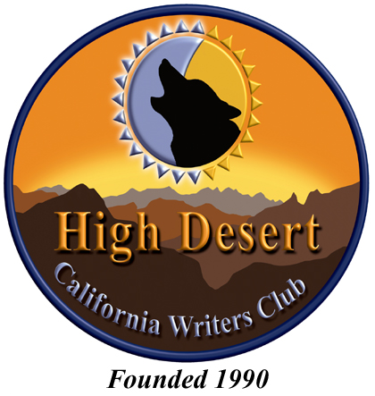

Published Book Announcement
Membership in the California Writers Club is open to those interested in learning or perfecting the craft of writing, including those ancillary fields such as illustration and marketing that enhance the writing experience.

The High Desert Branch is mandated at the state level to maintain a membership base of at least 51% ACTIVE/PUBLISHED members. (Members who are not yet published are listed as STUDENTS or ASSOCIATES.) To help us maintain that level, it is important that members notify the club when they release a new book. Towards that end, please complete the form below and submit it to the HDCWC Membership Chair when your book has been published. (See list of current board members provided in this packet for contact information.) For your convenience, the form is also available online at www.hdcwc.com.

If possible, please include a JPG, GIF or PNG file of your book’s cover.

PLEASE CHECK THIS BOX IF THIS IS YOUR FIRST PUBLISHED BOOK.

- MEMBER’S NAME:______________________________________________________________
- PUBLISHED AUTHOR’S NAME:_____________________________________________________
(if different from member’s name)
- BOOK TITLE:___________________________________________________________________
- GENRE:_______________________________________________________________________
- FORMATS:_____________________________________________________________________
(hard copy, e-book, audio book)
- DATE OF PUBLICATION:__________________________________________________________

__________________________________________ ____________________________
Member’s Signature Date

